

**Asian 498C**

Spring 2022  MW 2:30-3:20 PM, PST [SAV](https://www.washington.edu/students/maps/map.cgi?SAV)  156

**Instructor Details**

* Professor: Amy Snyder Ohta, Ph.D., Associate Professor
* Office Hours: Wednesdays 11:30-12:20 and by appointment
* Office Location: Gowen 247. Online at https://washington.zoom.us/my/aohta
* Email: On Canvas. For matters not specific to the course, or for time-sensitive matters, please use aohta@uw.edu.

**COVID-19 and Class Modality**

Synchronous classes may be offered face-to-face or via zoom.

**Class Overview**

This is a Japanese language course focused on developing independent language learning skills and Japanese language reading, writing, speaking, and listening skills via Japanese media, which, in this course, is Japanese songs. The class is taught in Japanese. Students select their own songs to learn from, or use a teacher-selected song each week, and create their own textbooks to learn from their songs of choice. This class is two credits, and meets two hours per week. Four hours per week of Japanese language homework is expected for this course. The course meets in the assigned classroom or on zoom.

**Prerequisites**

Completion of Japan 202. Enrollment in Japan 203 is preferred. Higher level students may enroll on a space-available basis.

**Learning Objectives**

* Develop independent Japanese language learning skills
* Develop skills to create a personal/social environment to support independent language learning, including arranging for social support and accountability structures needed
* Create goals related to language learning through songs
* Find appropriate and motivating songs and related media to use to study Japanese
* Create own language study materials
* Develop vocabulary and language skills through studying, engagement with media, and talking about Japanese songs and related media.

**Required Materials**

* Laptop or tablet device to bring to class
* Materials to make your own textbook for the class, which can be electronic or paper.
* Paper or tablet for hand-written assignments. Tablet is handy for handwriting on your digital textbook pages if you use powerpoint or some other software to make your textbook.
* Mic, headphones/earbuds and video cam for classes on zoom.

**Study Groups**

Students work in pairs or small groups in class. There are also small groups for discussion work on Canvas. The goal of using groups is to create a productive learning community for students by maximizing participation and minimizing stress.

**Effort Required**

The policy of the UW curriculum committee is that each credit multiplied by 3 is the amount of time a course should take per week. Thus, this course requires 6 hours per week of work, including time spent attending class, studying, and doing homework.

**Song Selection**

In this class, students choose the materials they want to study. Each student will choose one song per week.

* Choose a song that you can learn from. Don't select a song that you already have memorized or know well (in terms of language), but one that is less familiar to you.
* *Sensei's songs*, selected by the professor to be accessible for language learners, are available as options each week.
* Depending on a song's difficulty and length, students may learn more or less of the language from the song, depending on their goals and what they can accomplish during homework hours.

Because the goal of this course is learning Japanese, please spend time studying and using your Japanese, not searching for the perfect song. If you want to spend a lot of time searching for a song, that doesn't count as homework time for the course.

**Components of the grade**

Grading is based on a variety of categories, involving both learning and applying new knowledge. There are no exams in this course.

Participation: 25%

My Textbook: 20%

Handwritten Japanese Practice: 15%

Oral Japanese Practice 15%

Self-Assessment Online Discussions 15%

Singer/Song Presentation 10%

***Policy on Late Work:*** Effective language learning is a cumulative process that results from consistent and regular engagement with target language materials. Late work, thus, is only accepted within the short assignment availability window for each assignment. Late assignments are docked 25%. Please note that on-time work is also counted, positively, toward the participation grade.

***Participation:***

Participation and preparation are graded according to this rubric. (The "video on" requirement is only for classes held on zoom. None of our classes are recorded, to protect student privacy. If a student has difficulty with this requirement due to individual circumstances, please contact the professor for assistance and an adjustment of the requirement.)

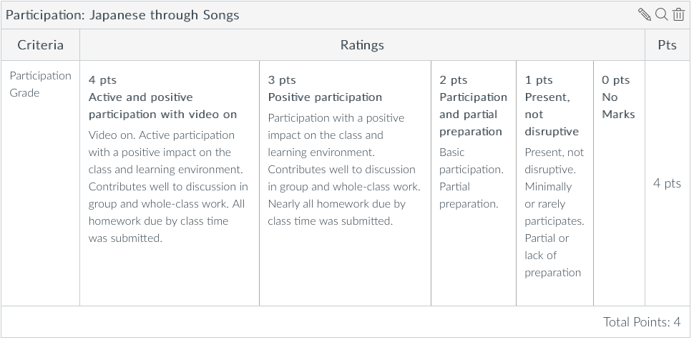

***My Textbook***

Each student will create their own textbook for this class, for their own use. Textbooks may be made electronically, by hand, or use a combination of handwritten and printed out materials, scrapbook-style. Feel free to use the powerpoint template provided, or to create your own format.

Each song’s textbook pages must include, at minimum, the following sections:

* Song title, lyrics and links (Can be printed out/copied from the web)
* Vocabulary list (Focused on what you want to learn from the song)
* Focal lines, phrases, or verse(s) (Again, based on what you want to learn)
* For conversation in class (Conversation topic ideas, song content you want to talk about, Q/A ideas, reflections on the song (you can write up your reflections, and then talk about them in class), etc. )

You are welcome to add other headings/information as they like to their textbooks. *My Textbook* is for your own use, and doesn’t have to be artistic or professional in appearance. Spend your time learning Japanese, and make your *My Textbook* with that focus.

***Handwritten Japanese Practice***

Using your textbook for reference, practice Japanese by writing out, by hand, vocabulary, phrases, etc., to help you learn new words. This may, of course, include learning new kanji. If you don’t already know the kanji, practice writing them over and over. If you do already know the kanji, write the word using kanji once, and then practice writing the pronunciation over and over.

***Oral Japanese Practice***

Using the recording function on Canvas, record yourself talking about your song in Japanese. You can say anything you like. Some ideas: Read out a line and explain it in Japanese, talk about the singer, talk about why you chose the song, talk about the content of the song, talk about words from the song you want to learn, use words/phrases from the song in your own conversation on any topic.

***Self-Assessment Discussions***

On Canvas in your study groups, write a paragraph (300 words) reflecting on your Japanese language learning, through songs for the preceding week. What is going well? What have you been learning from your own materials and/or from other students? What challenges are you facing? What is inspiring you? What would you like to do differently, or continue to do, between now and the next self-assessment? After writing and posting your paragraph, comment on two peer posts.

***Singer/Song Presentation***

This is the final presentation for the course, shared in small groups. Choose a song or a singer/group to share with the class. In Japanese, talk about the song, singer, your related experiences, etc.—organized however you like. Include visuals. Presentation length will be announced in class. On presentation day, each student will present a number of times with different audiences.

**Weekly Activity Flow**

***Week 1***

Monday Class

* Introduction to the course
* Sensei’s song of the week
* Favorite singers and songs
* Song selection
* How to learn Japanese from songs

Tuesday (Due by class time, Wednesday): Homework (1-2 hours of homework)

* Make textbook page(s) for your song pick for this week.
* Hand-written vocabulary/kanji practice. For example, repeatedly write words that you want to learn, writing out phrases/lyrics containing those words, etc

Wednesday Class:

* This week’s song. Activities may include
* Sharing song listening.
* Talking about your songs and explaining the content of the lyrics.
* Reading aloud lyrics
* Sharing new words and explaining them to each other
* Talking about singers, idols, and other related interests

Thursday through Sunday: Weekend Homework (2-3 hours of homework)

* Song studying
* Song monologue: Record yourself talking about the song. You can also read the song aloud and record that.
* Song selection for Monday
* Preparation to talk about the singer. If you are repeating the same singer, then share something new about them.

***Weeks 2-9***

Monday Classes:

* Last week's song:
  + Discuss learning from last week’s song
  + "Self-tests" (ungraded) (If you memorized part of the song, your self-test can be reciting (or singing, or rapping) what you memorized)
* This week's song
  + Sensei’s songs of the week
  + Sharing what you picked
  + Talk about singers and songs chosen
  + Song listening
  + Work on this week’s song

Tuesdays (Due by class time, Wednesday): Homework (2 hours of homework)

* Make textbook page(s) for your song pick for this week. You may use a song of your choice, or one of Sensei's songs of the week.
* Hand-written vocabulary/kanji practice. For example, repeatedly write words that you want to learn, writing out phrases/lyrics containing those words, etc

Wednesday Classes:

* This week’s song. Activities may include:
* Sharing song listening.
* Talking about your songs.
* Talking about *My Textbook* pages
* Conversing using your “In-class conversation ideas”
* Reading aloud lyrics
* Sharing new words and explaining them to each other
* Talking about singers, idols, and other related interests

Thursdays through Sundays: Weekend Homework (2 hours of homework)

* This week’s song studying
* This week’s song monologue: Record yourself talking about the song. You can also read the song aloud and record that.
* Song selection for Monday
* Be ready to talk about the singer Monday (informal conversational sharing)

**Week 10: Presentations**

* Half of the students will present each day. Presentations are in small groups. Non-presenters each day serve as audience members, and will submit an assignment where they talk about the songs from the presentations they liked best, and what they learned from the presentations.

**Other Policy Items**

*Errors:* I am always happy to hear from students who have noticed errors in my course materials, whether this syllabus, the Canvas page, my lectures, etc. Please email me with information on any error(s), and I will do my best to make corrections promptly.

*Inclusion:*UW strives to create a welcoming environment for all students. Please speak to or email the professor for assistance related to inclusion in the classroom learning community. Examples are personal pronouns, [disability](http://depts.washington.edu/uwdrs/), neurodiversity, [accommodations](http://depts.washington.edu/uwdrs/current-students/accommodations/), privacy, disclosure, [religious observance schedules](https://registrar.washington.edu/staffandfaculty/religious-accommodations-policy/), and learning preferences. When there is a safe and open atmosphere for discussing our diversity, it creates a better learning environment for all.

*Disability Access and Accommodations:*If you have already established accommodations with Disability Resources for Students (DRS), please let me know so that we can discuss your needs in this course. To arrange accommodations for a temporary health condition or permanent disability (conditions include but not limited to; mental health, attention-related, learning, vision, hearing, physical or health impacts), please contact DRS (206-543-8924 or [uwdrs@uw.edu](mailto:uwdrs@uw.edu) or [disability.uw.edu.)](http://depts.washington.edu/uwdrs/)DRS offers resources and coordinates accommodations, which are established through an interactive process.  It is the policy and practice of the University of Washington to create inclusive and accessible learning environments consistent with federal and state law.

*Accommodations for Religious Observances:*Washington state law requires that UW develop a policy for accommodation of student absences or significant hardship due to reasons of faith or conscience, or for organized religious activities. The UW’s policy, including more information about how to request an accommodation, is available at [Religious Accommodations Policy](https://registrar.washington.edu/staffandfaculty/religious-accommodations-policy/). Accommodations must be requested within the first two weeks of this course using the [Religious Accommodations Request form](https://registrar.washington.edu/students/religious-accommodations-request/).

*Incompletes*: Incompletes are only permitted as defined in writing by the University of Washington, within the limits outlined by UW academic policy.

*J-Info:*The Japanese faculty has an email listserv that distributes information on Japanese and Japan-related events, job leads, etc. To subscribe, go to [http://mailman.u.washington.edu/mailman/listinfo/*j-info*/](http://mailman.u.washington.edu/mailman/listinfo/j-info/)